

### Project Report

## Smart Generator Application

|  |  |
| --- | --- |
| **Name:** | **Student ID:** |
|  |  |
| Hassan Umar | 62953 |
| Shoaib Ali Naqvi | 63256 |

|  |  |  |
| --- | --- | --- |
| S.no | Content | Page no. |
| 1 | Proposal | 1 |
| 2 | Task Analysis | 2 |
| 3 | Use Case | 2 |
| 4 | Story Board | 3 |
| 5 | Prototype | 22 |
| 6 | Persona | 27 |
| 7 | Cognitive Walkthrough | 30 |
| 8 | Final UI | 32 |

# Abstract:

As in our day to day life electricity plays a vital role. But when power failure gets occurred then there is necessity of generator. But it is necessary that it require maintaining various parameter of generator such as current, voltage, fuel level, temperature. So it require regular testing. Therefore because of that it can consume some time and also require some human effort. So to reduce that efforts, there is system which can monitors the generator and also it can start and stop the generator using android application.

# Introduction:

This system consists of monitoring and controlling part of generator. There are various sensors vailable in generator which can monitor the value of fuel level, temperature, current, and voltage. In our modern life electric generator plays most important role to maintain the stability of power. Its Technological dependency is extremely crucial, monitoring these generators is a major, and important issue that every factory must consider, due to which each factory must have a maintenance team to check up on the vitals of the generator in a daily, hourly, and cyclic manner which requires a lot of hard work, in addition to inaccurate data readings due to the lack of automation. If the power failure occurred in colleges, industries, hospitals, educational institutes then the generator is used. In generator there are on and off manual switching is present. Here the man power is must to do this operation. In many Factories the generator placed in distance place so the process of ON the generator get some time delay, doing this by manually means, some important works get delay.

# Conclusion:

The important of this system is to contribute to the world as an advanced monitoring and control system, as it can be produced in other form to reflect different needs. This system assembled a mixture of system and dedicated them to a real issue were people related to the industry are facing, the idea doesn’t widespread in the world and will insure more productivity and make human life easier. As the Android application used it is very easy to handle this system. Because of this application the time and human efforts get reduced.

# Task Analysis:

* **Power on/off:** generator app will conform first you are at home or not if we conform that we are at home it will start automatically otherwise it will remain off
* **Fuel /oil alerts:** generator app will notify when fuel or oil will about to finish
* **Customer support:** In this application we have save the information of customer care app will show the complete information of workers as well for the maintenance of the generator
* **View runtime:** This application will notify that how long your generator has been running
* **View Voltage:** It will also tell the user that how much voltages he has been getting and whether he wants to turn on the generator or not
* **Mechanical Issues:** The user gets the notification whenever generator gets some issue or it needs service

# Use Case:

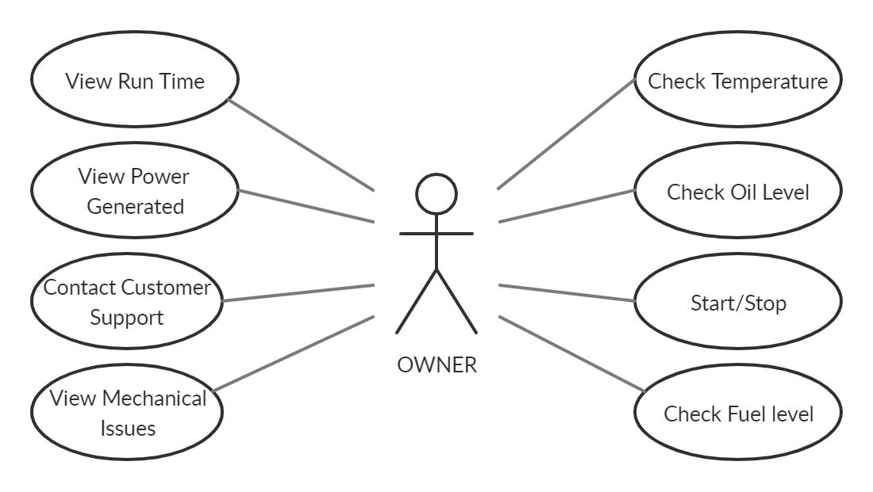

# StoryBoard:

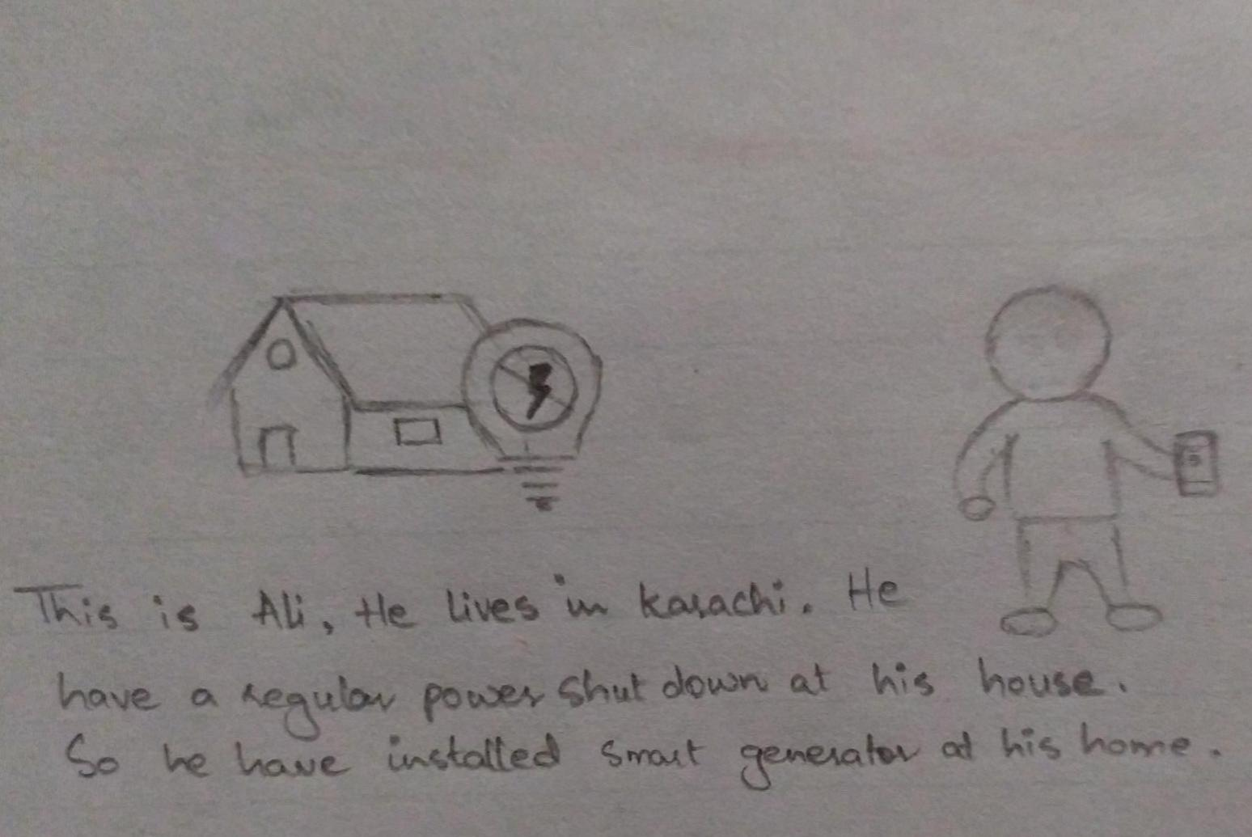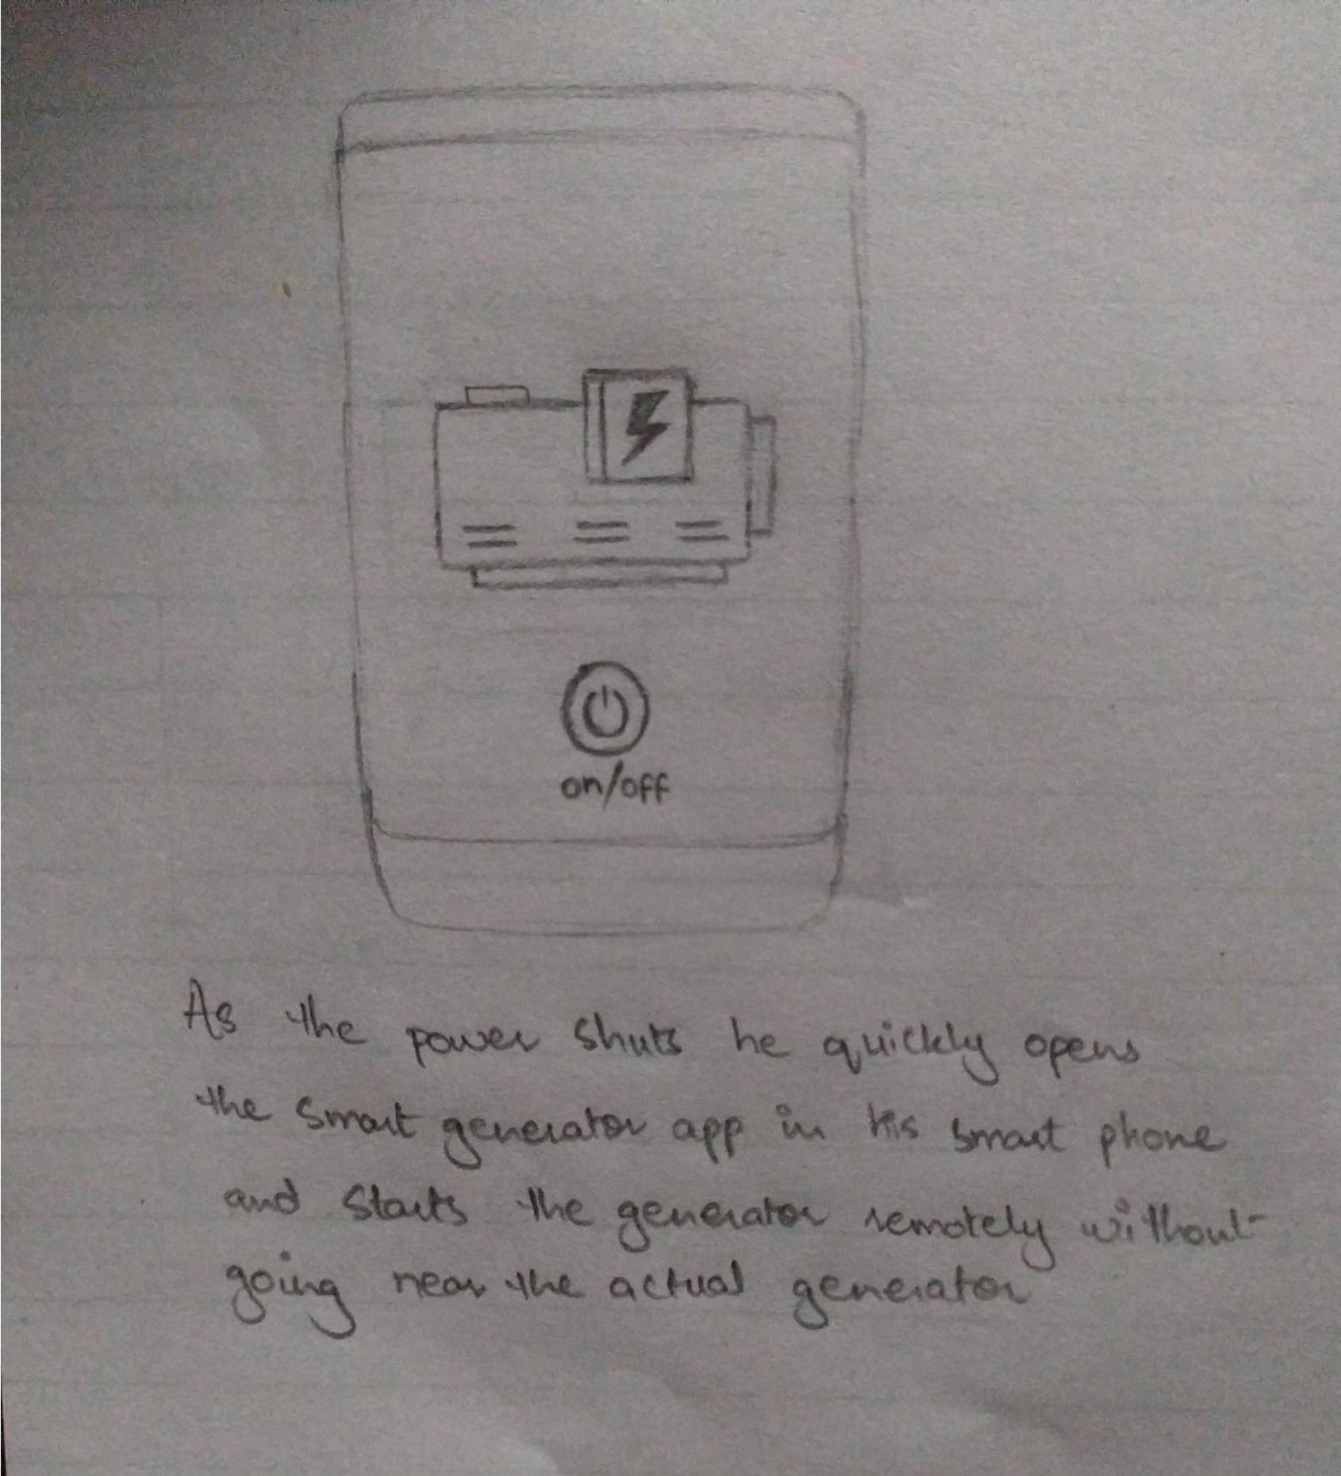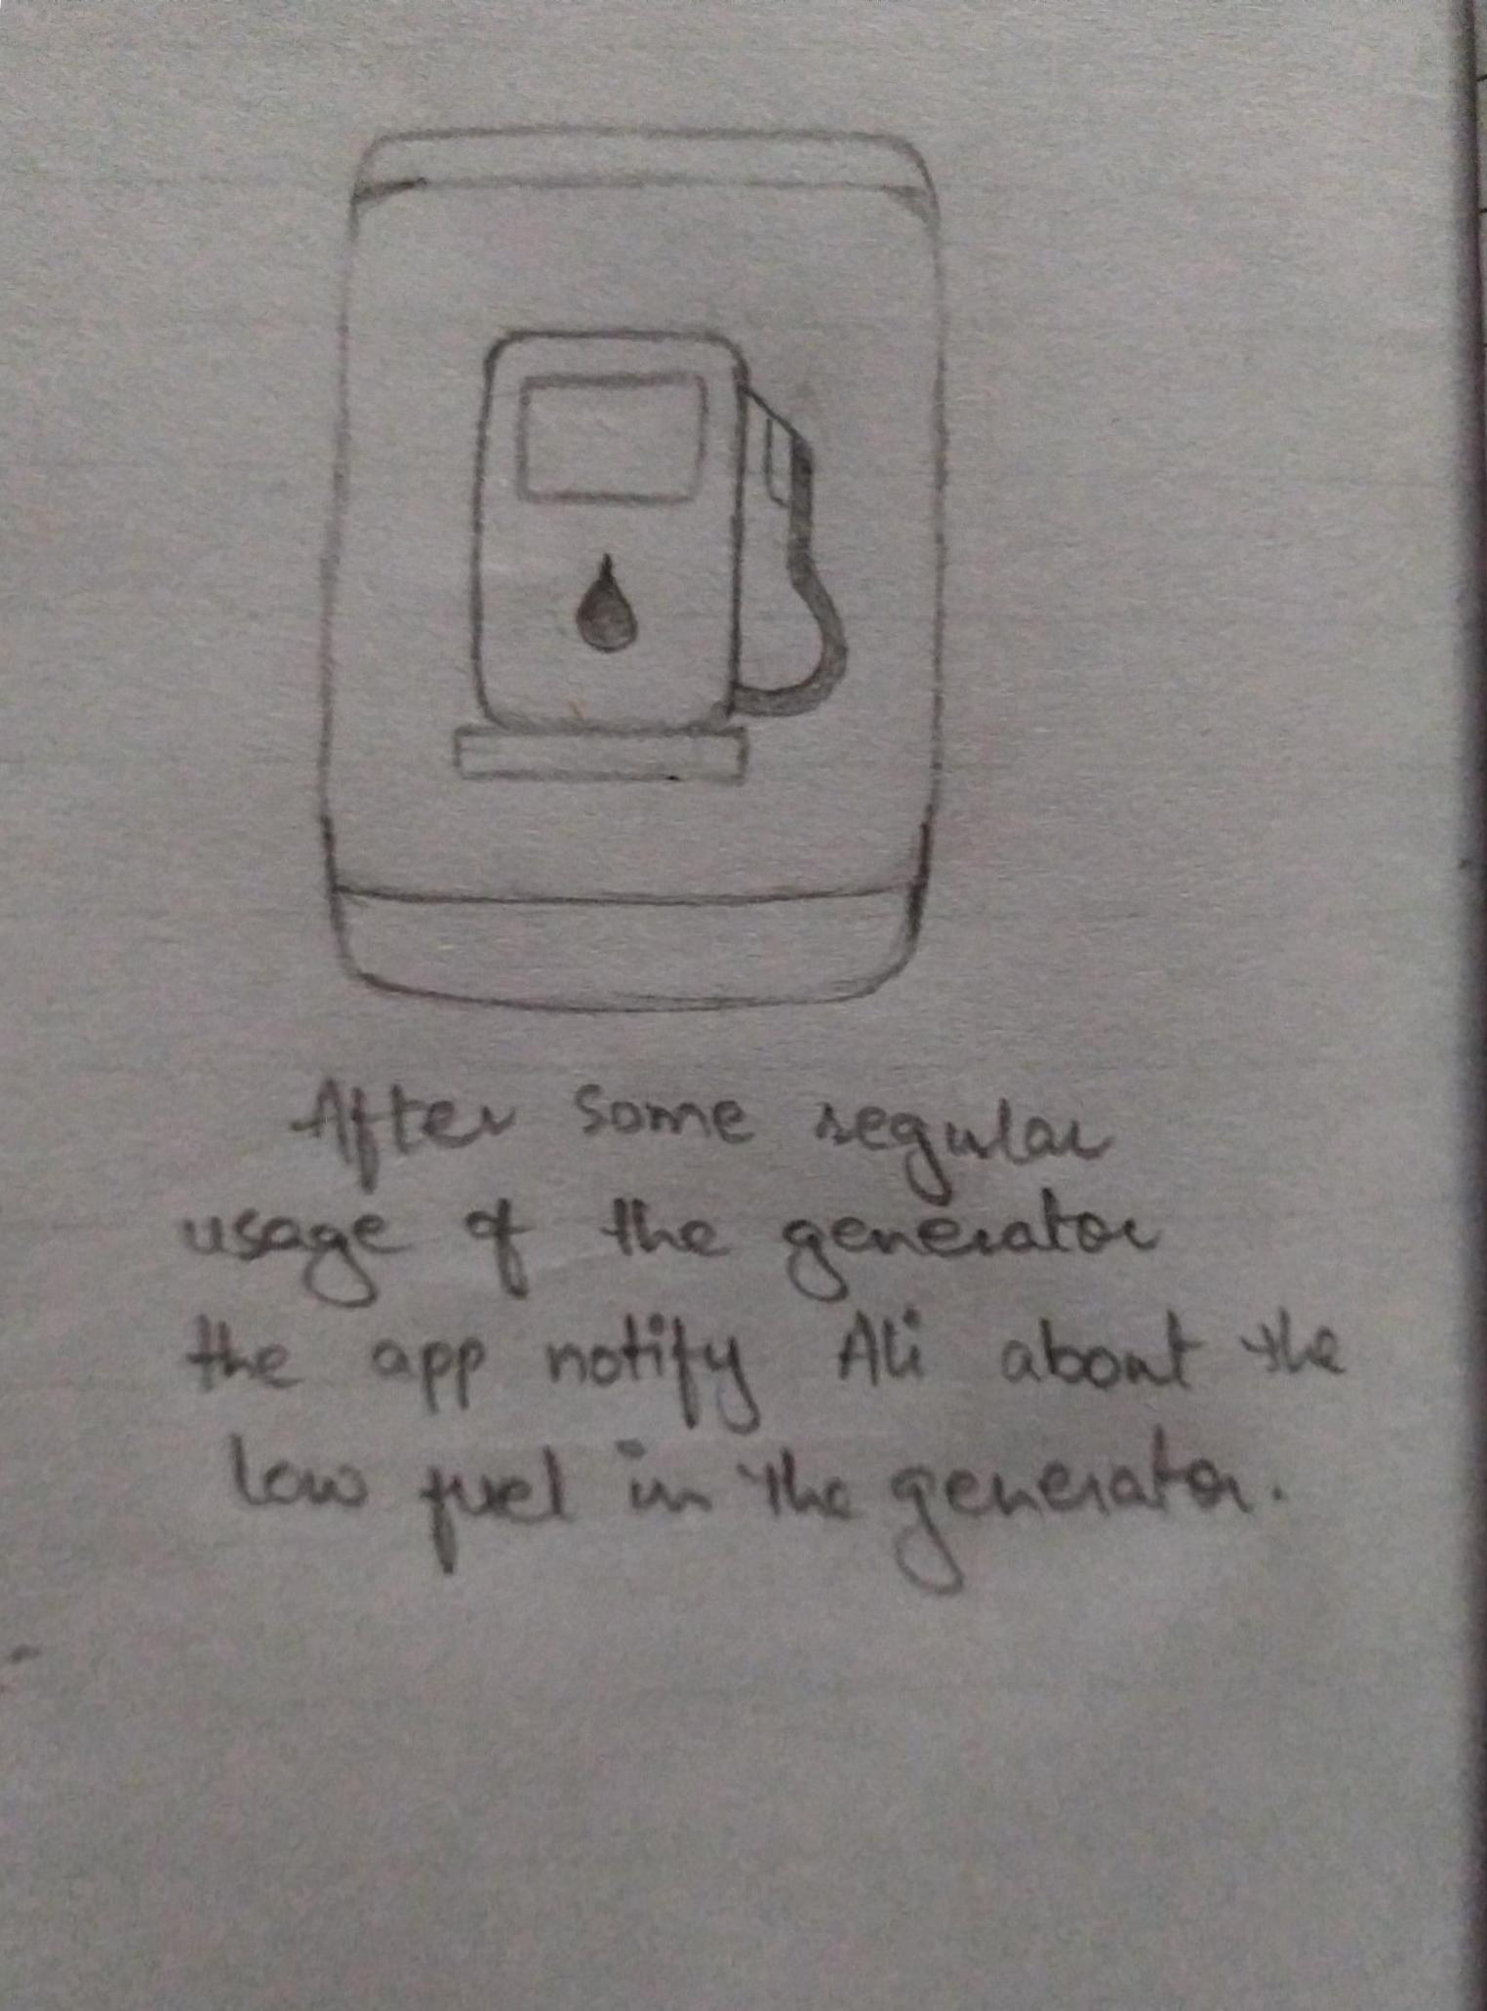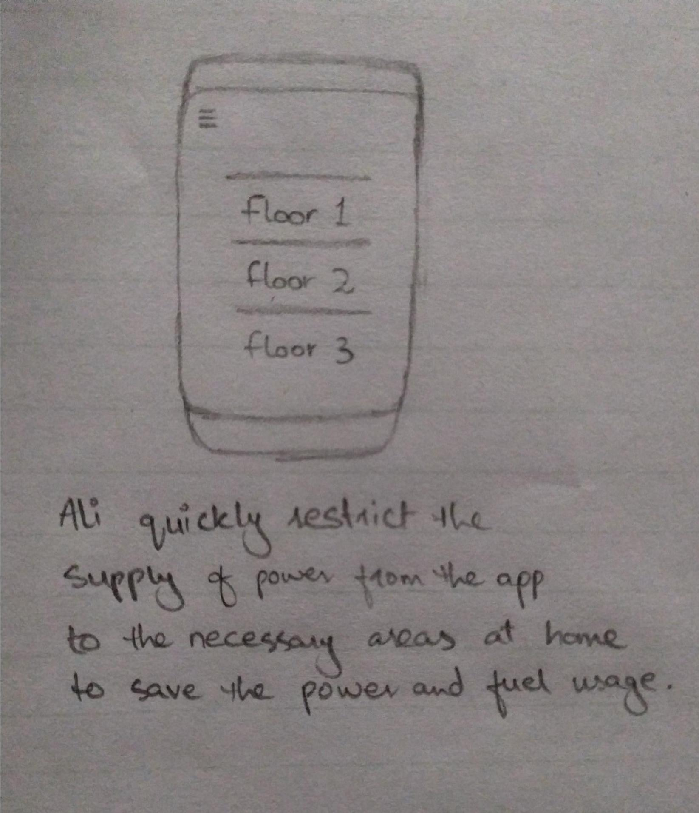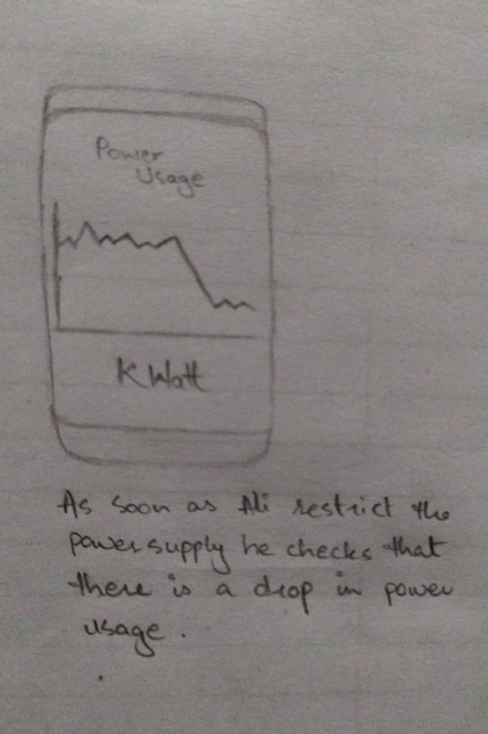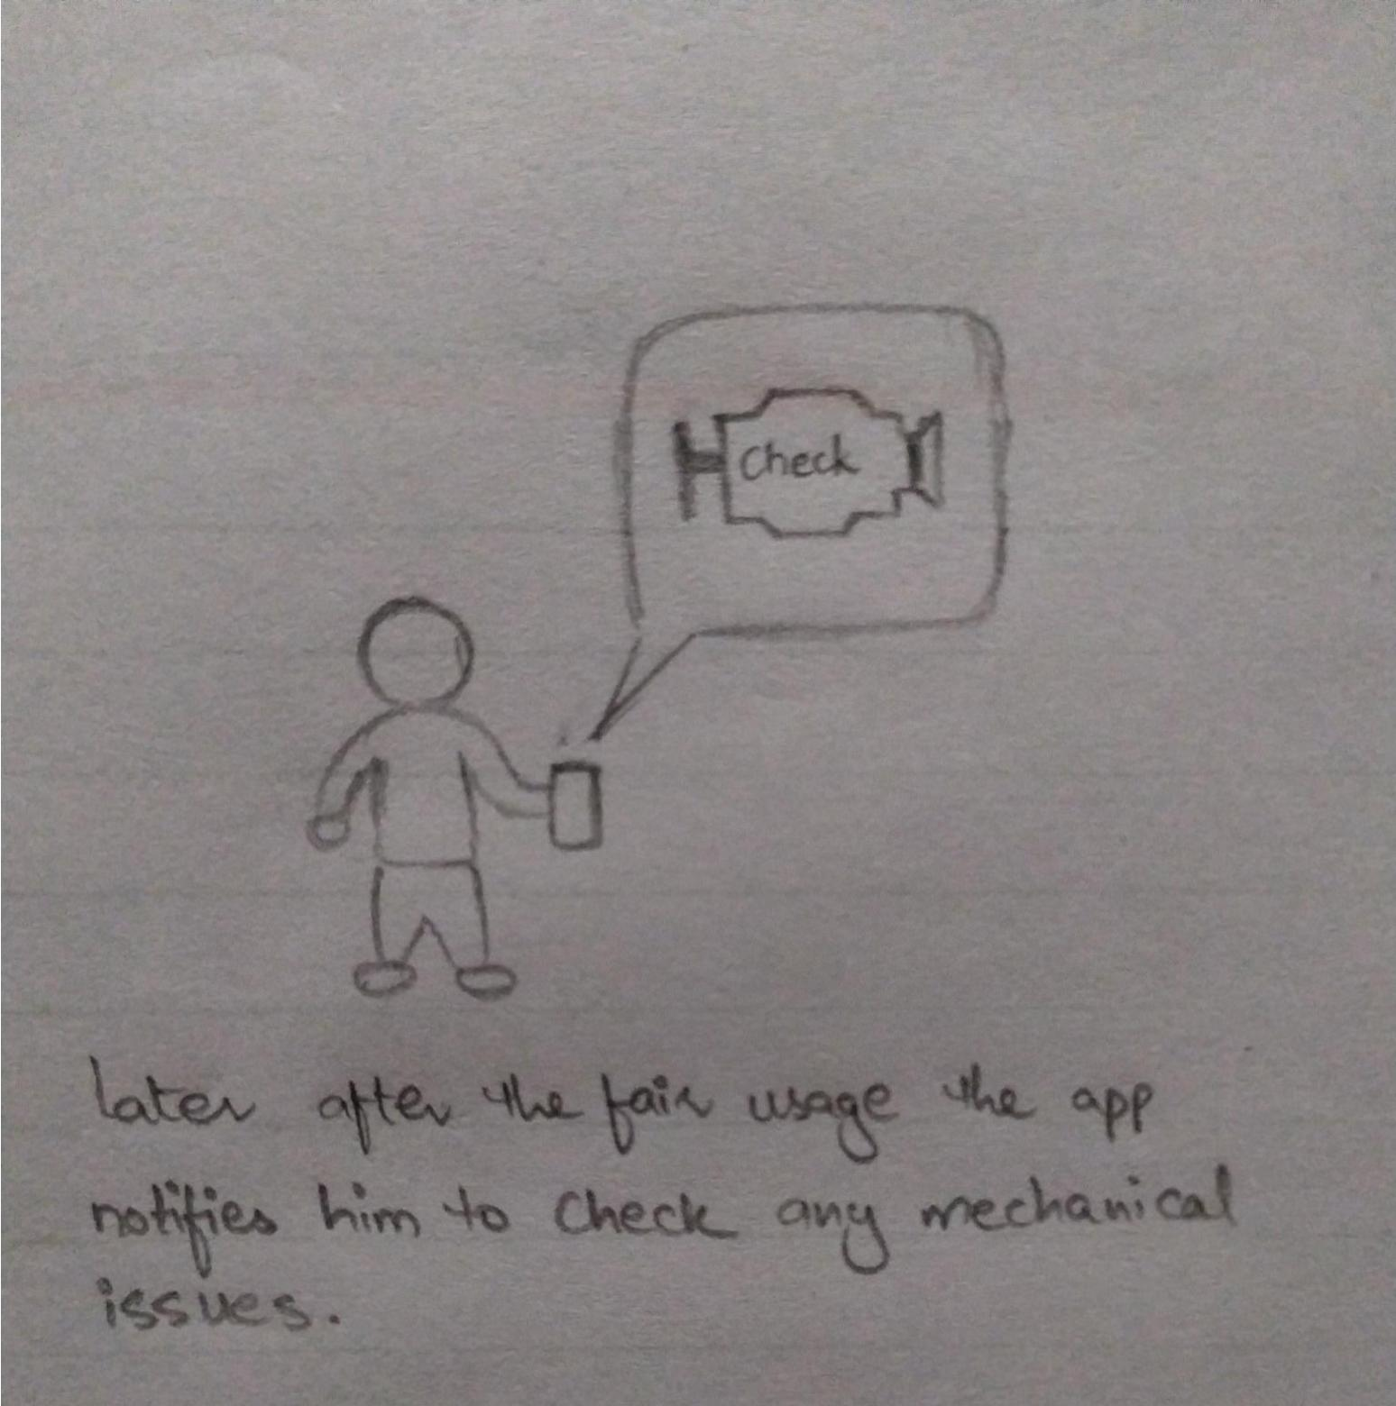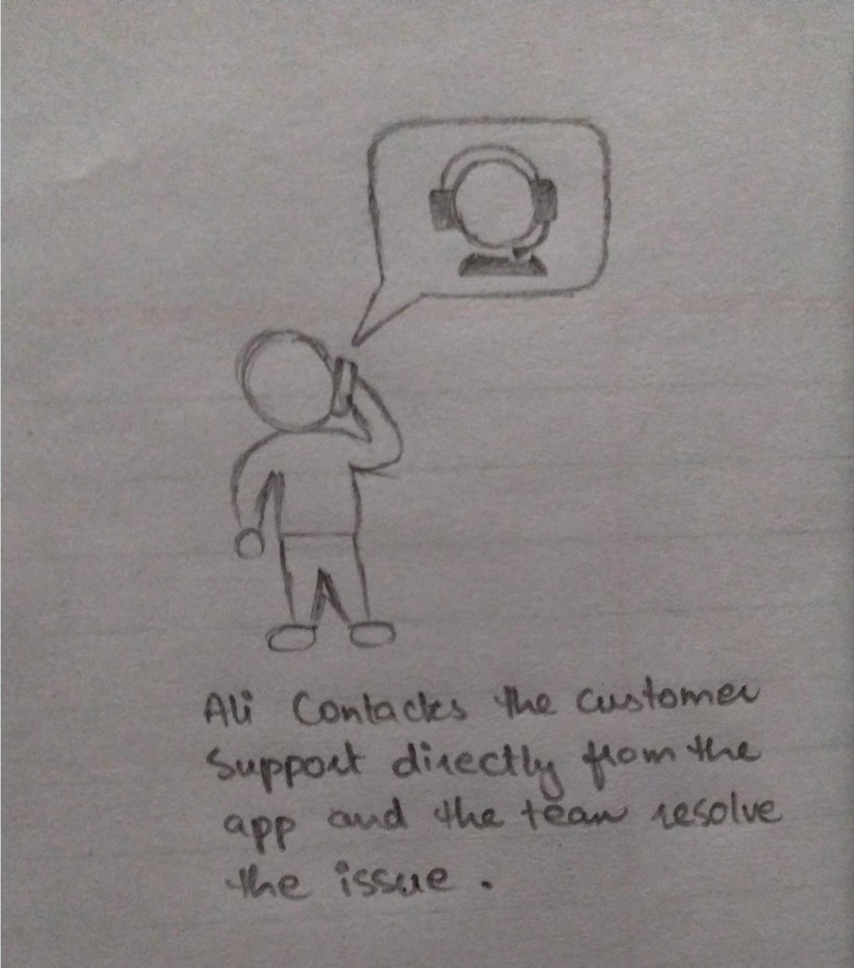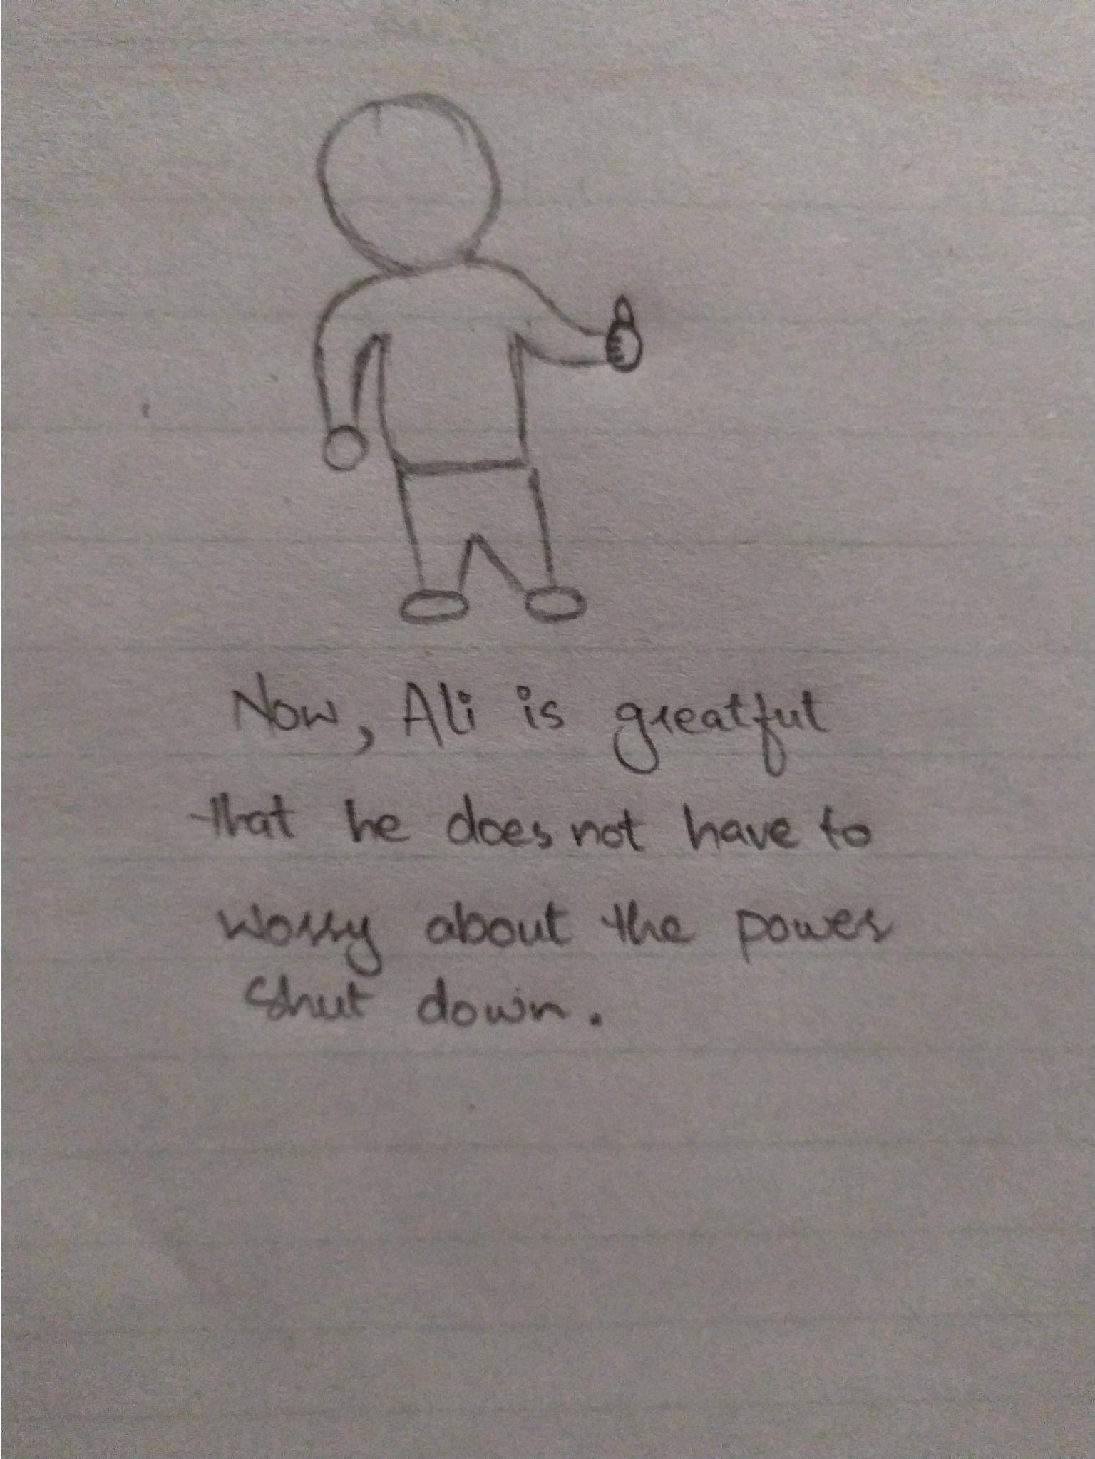

# Prototype:

# C:\Users\aa\AppData\Local\Microsoft\Windows\Temporary Internet Files\Content.Word\2020_07_21 7_21 pm Office Lens (1).jpg

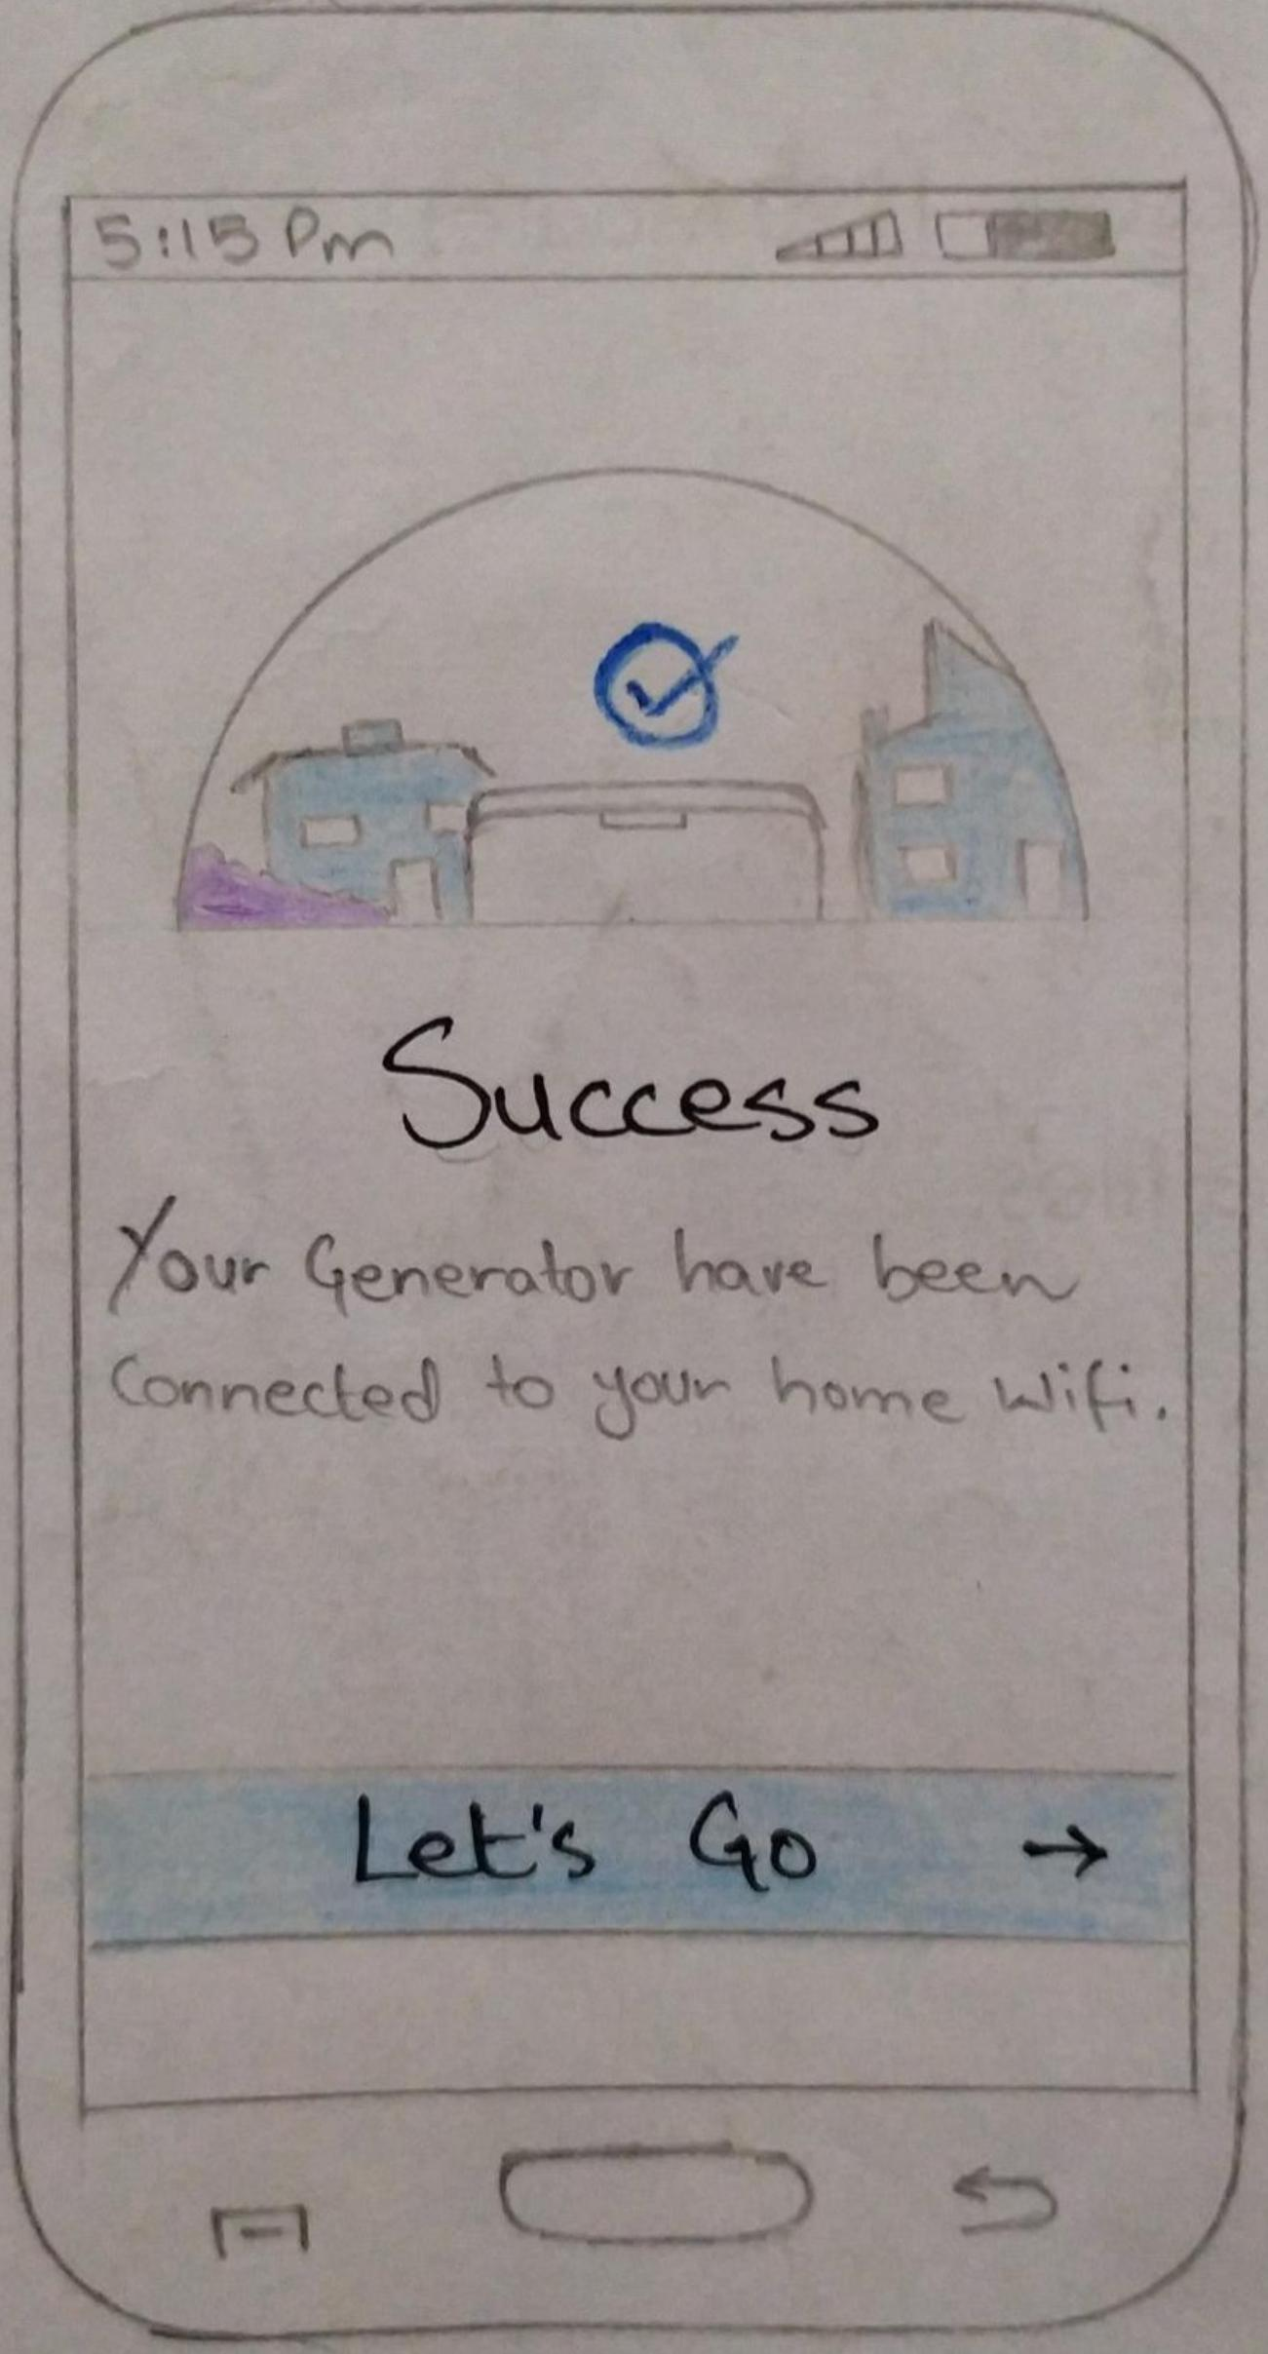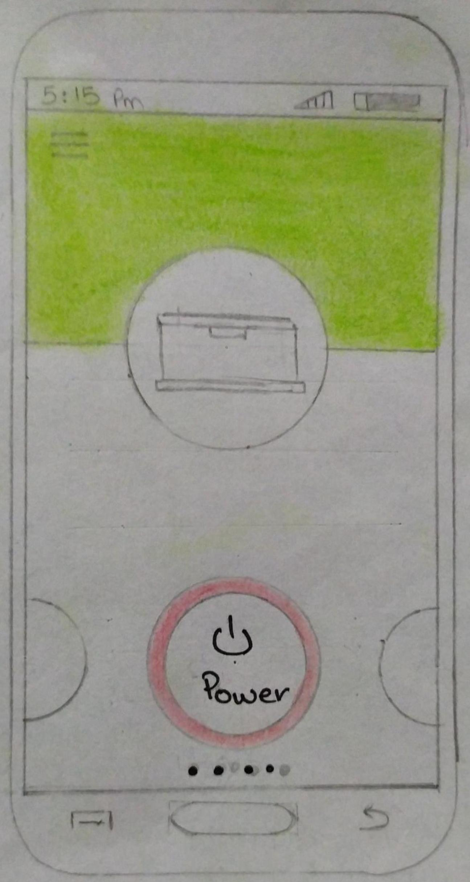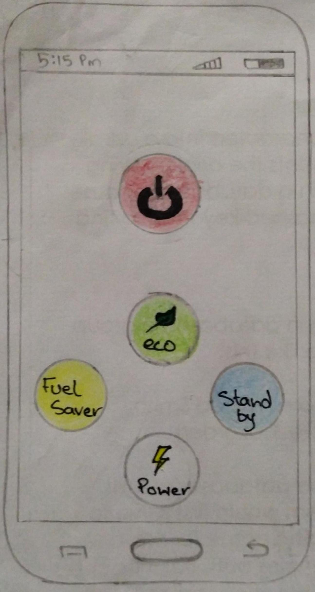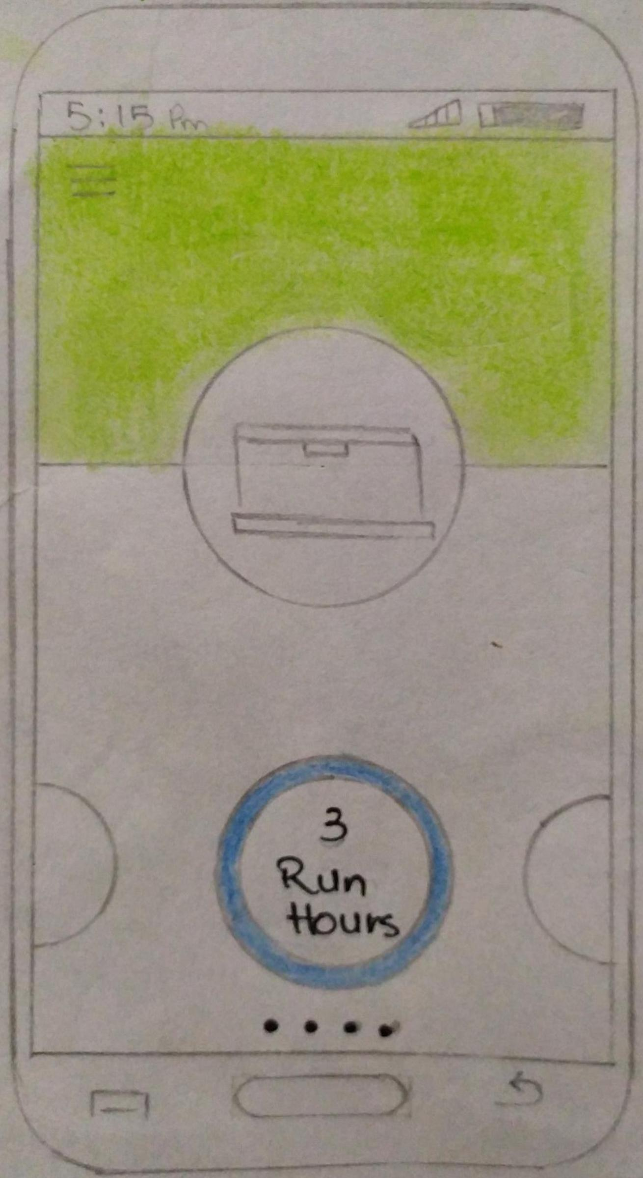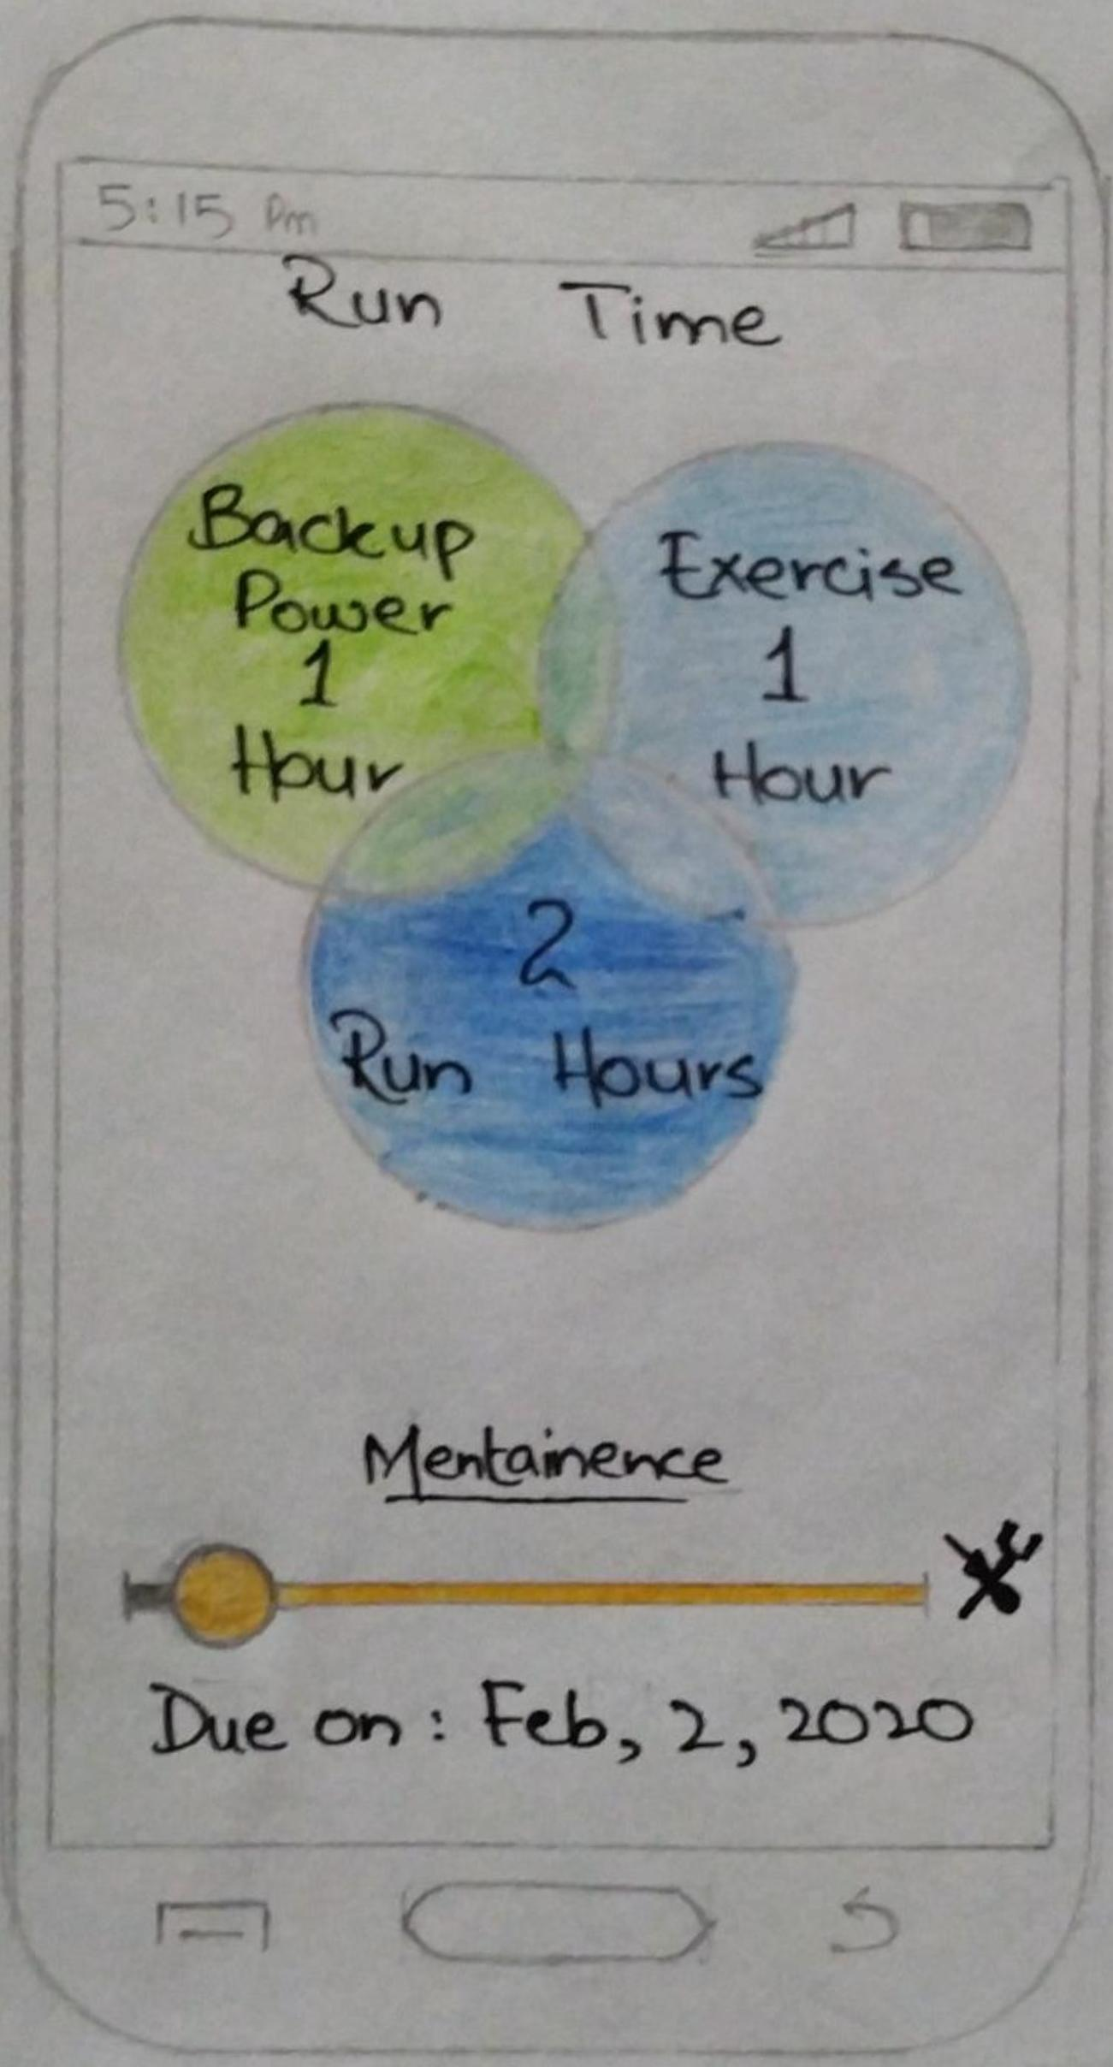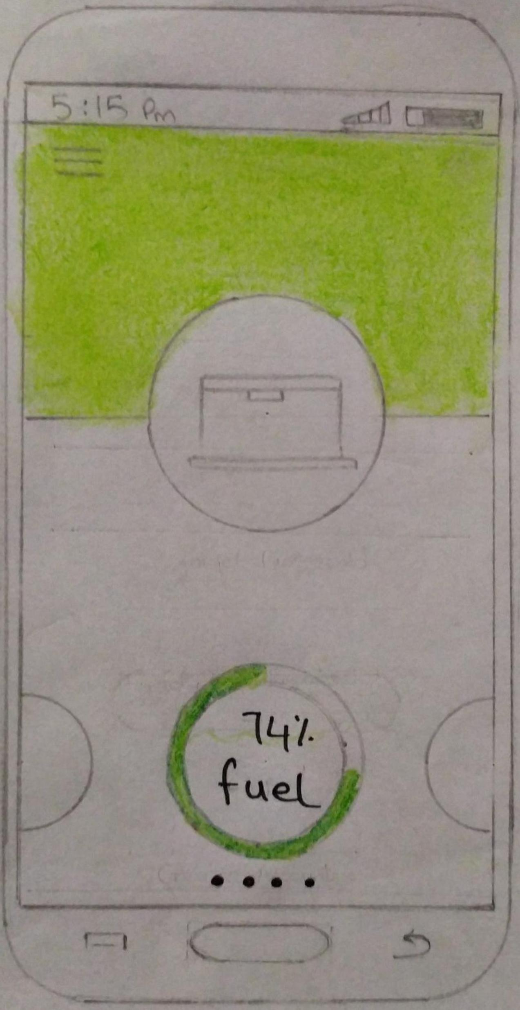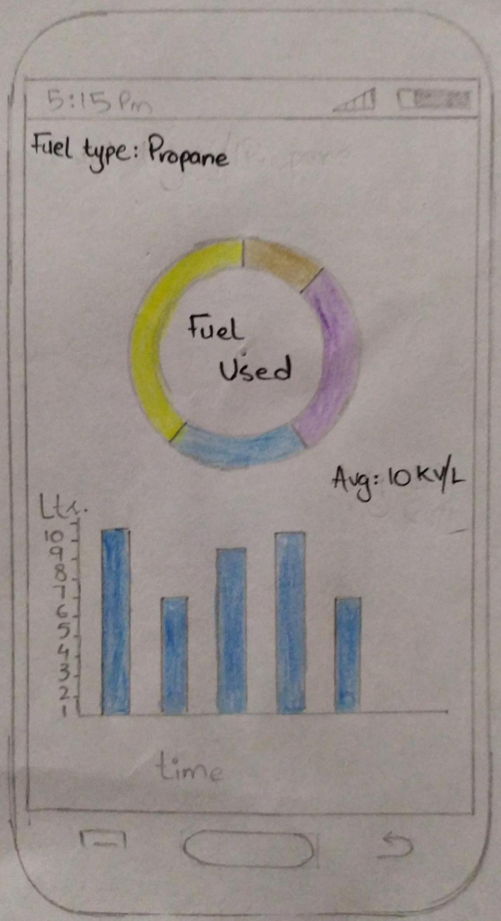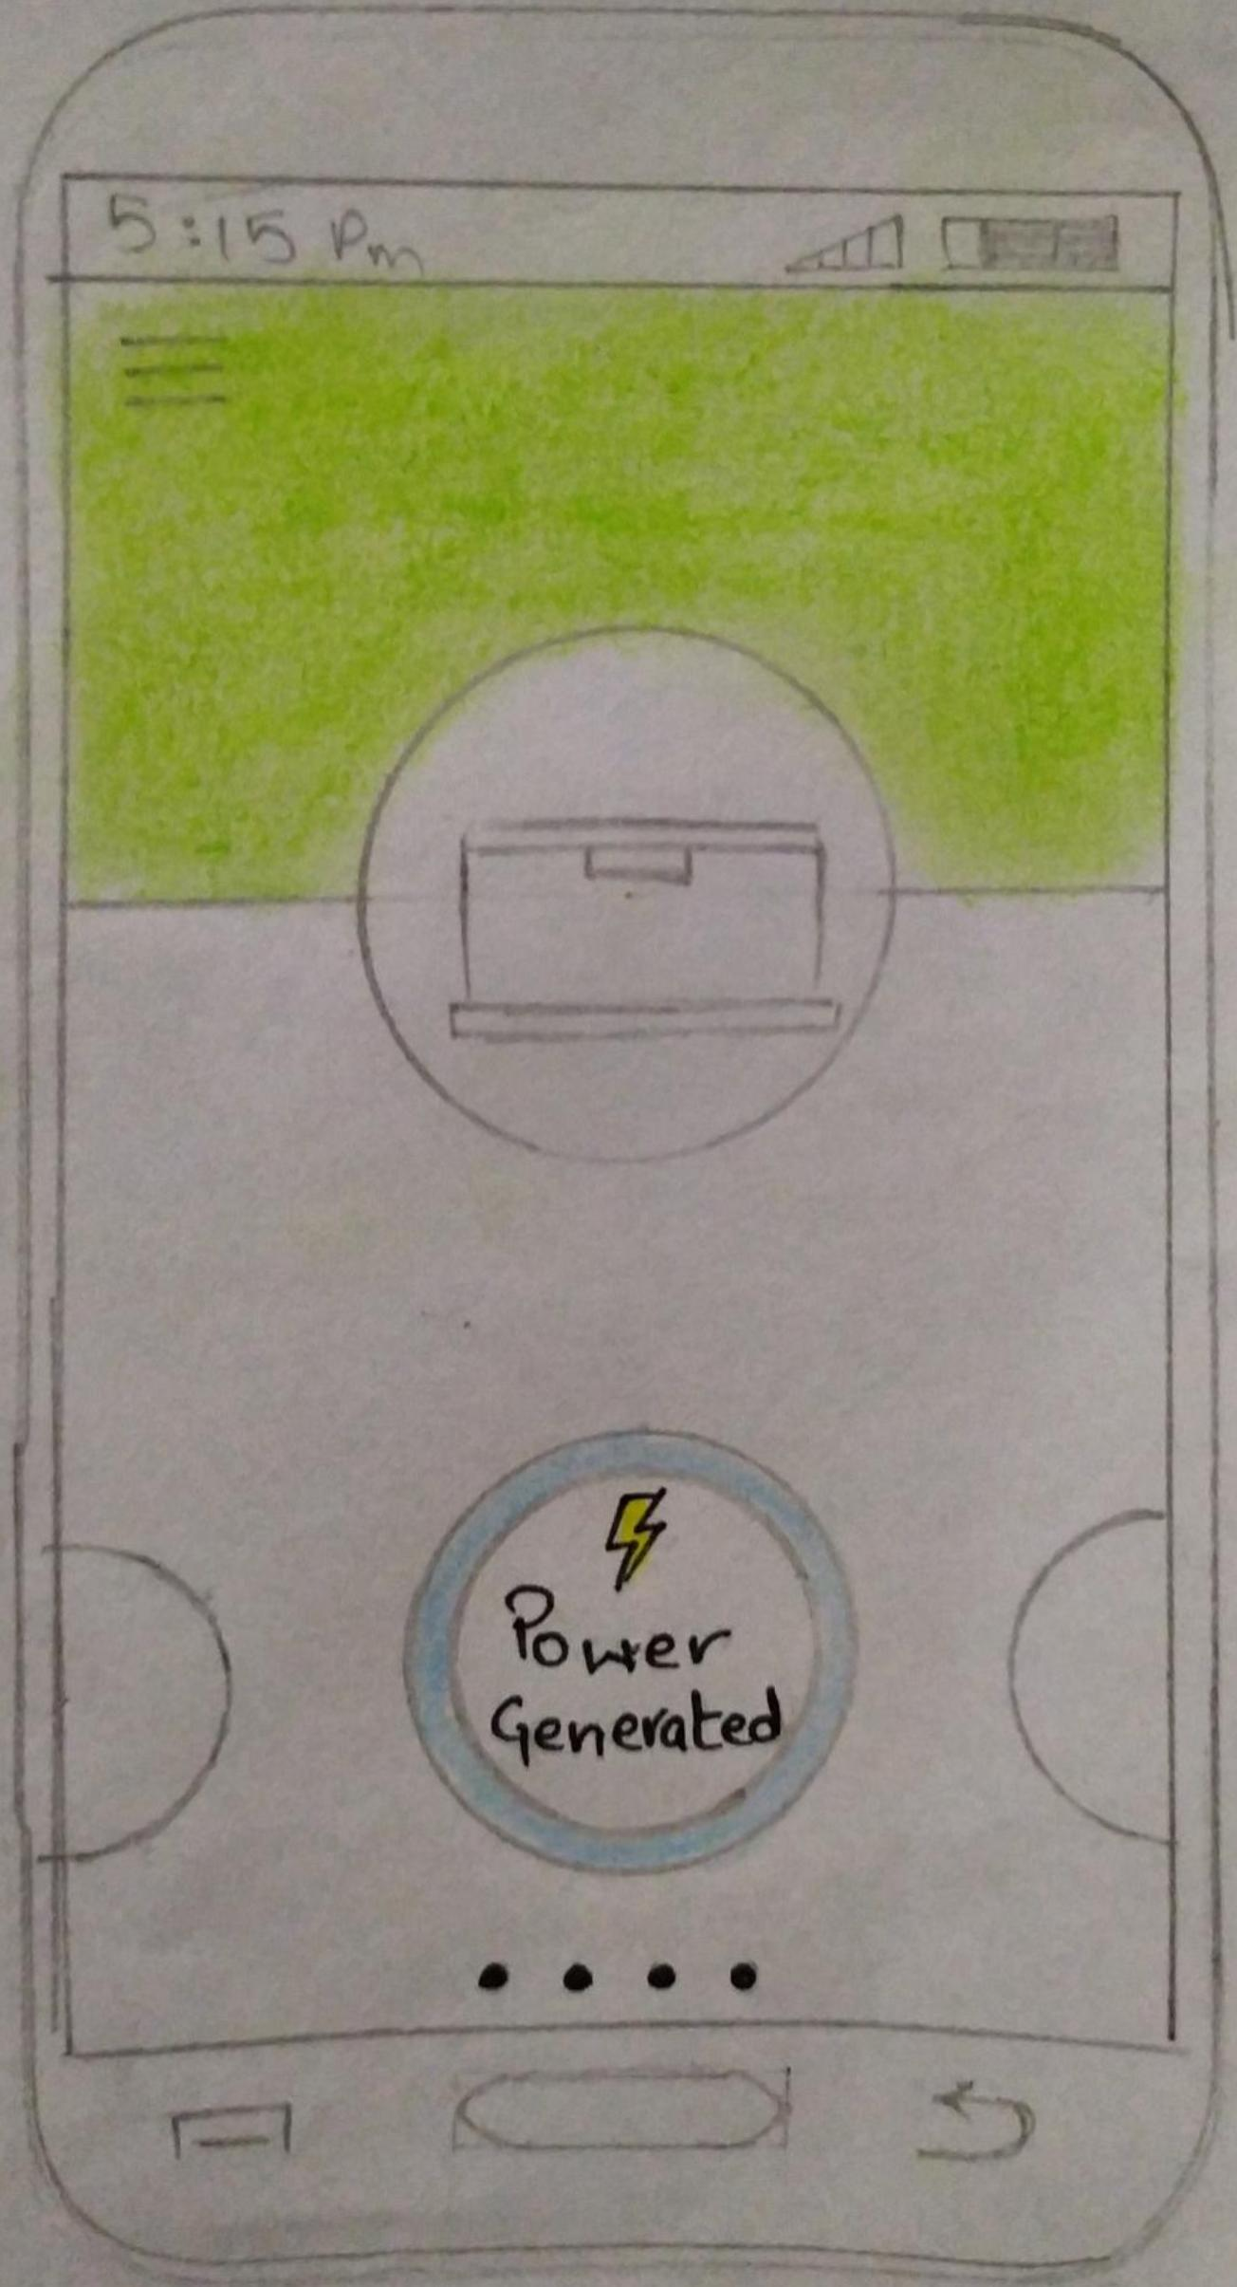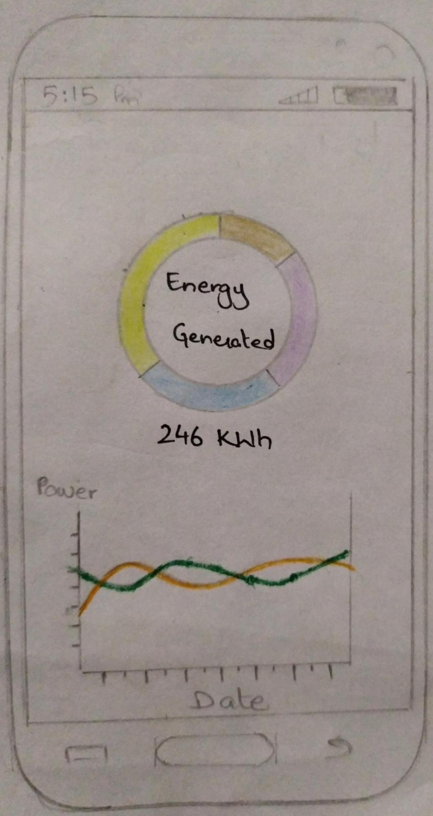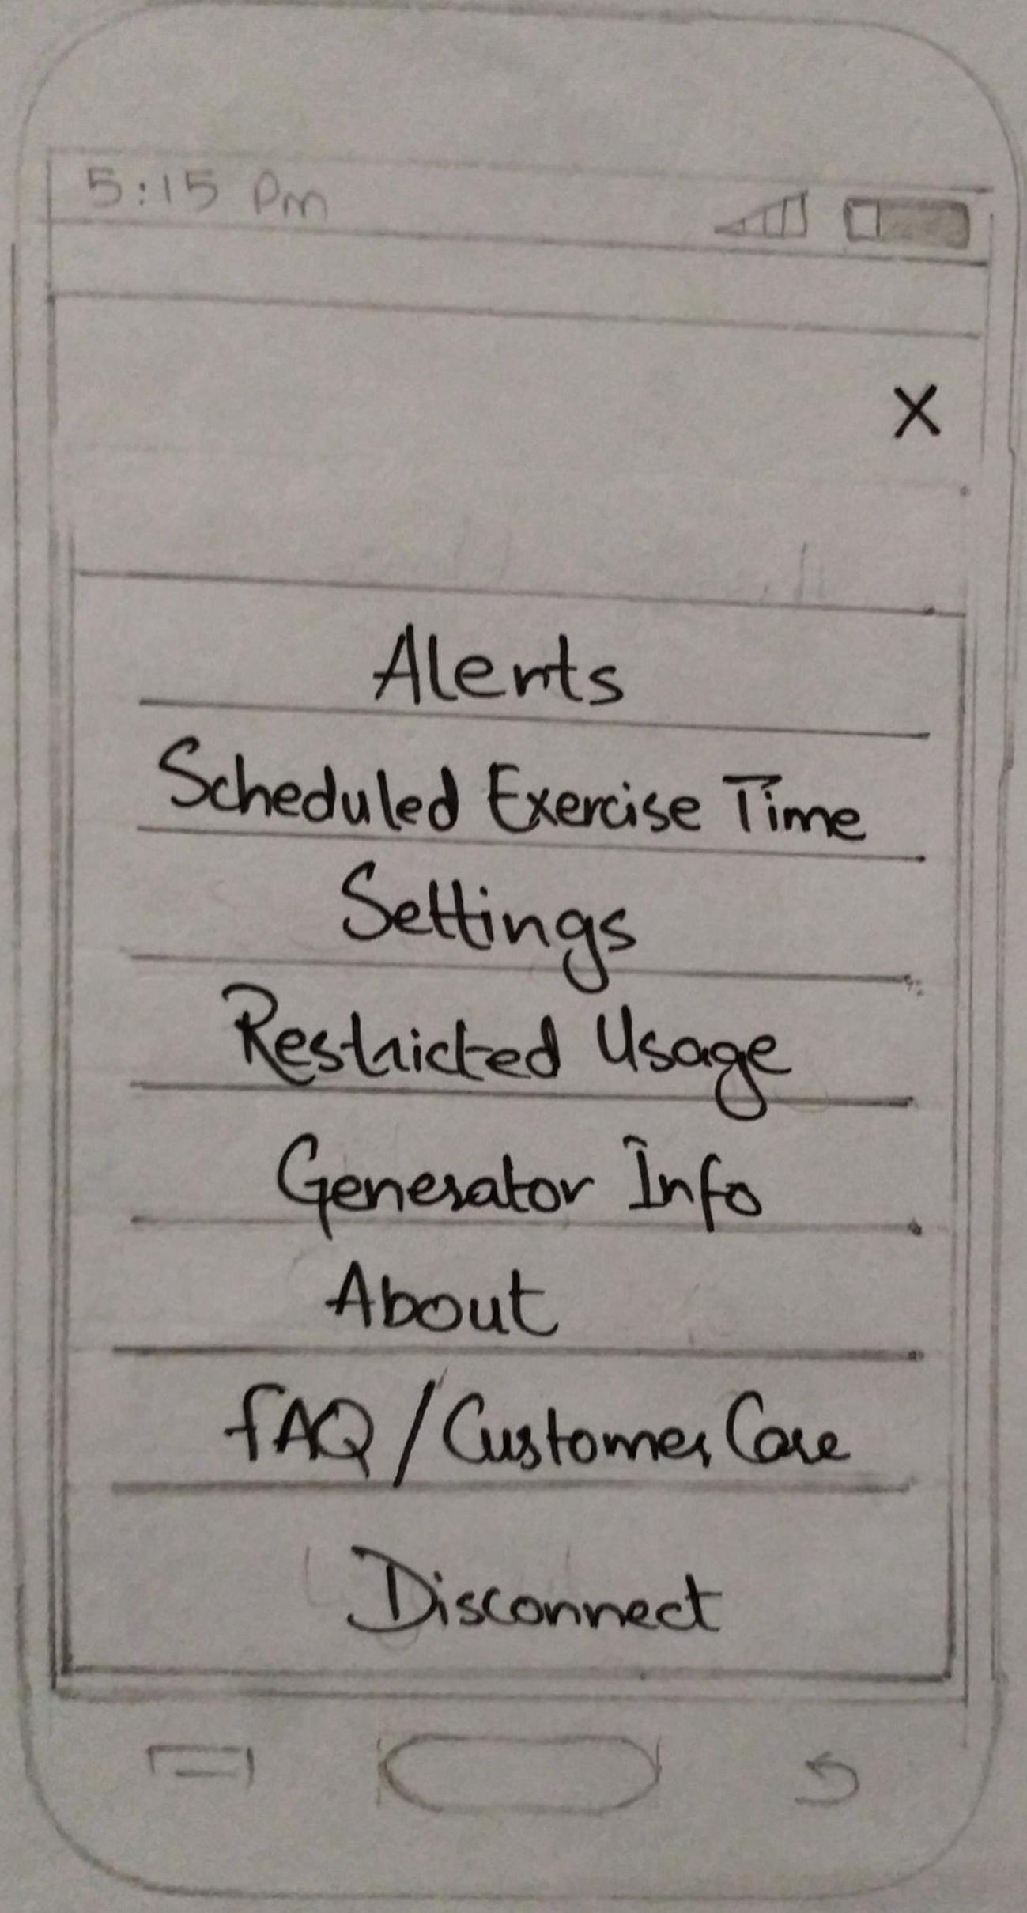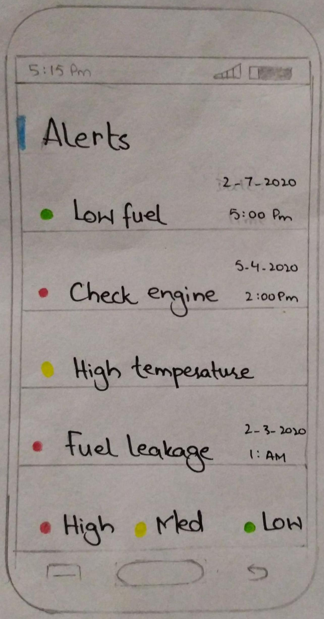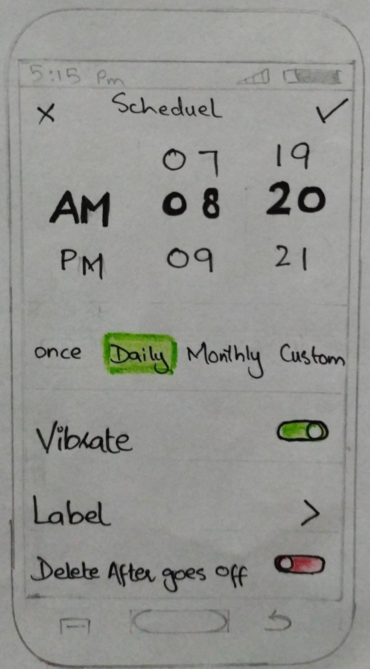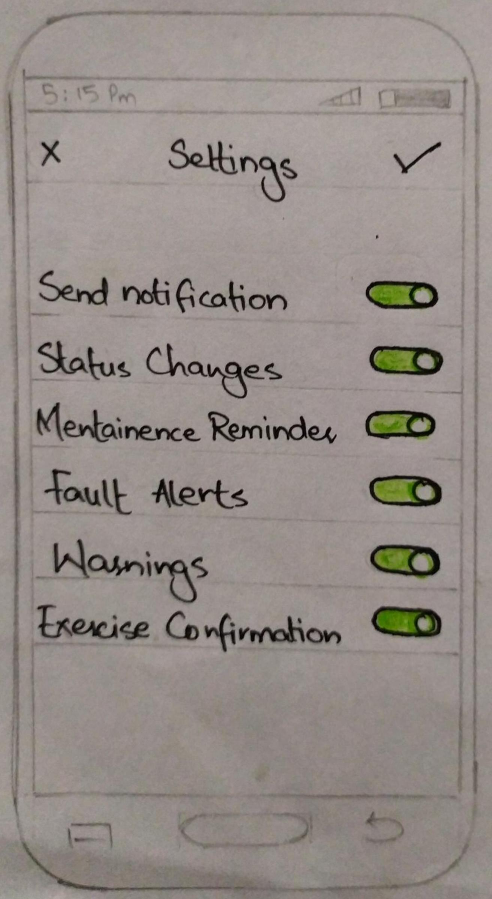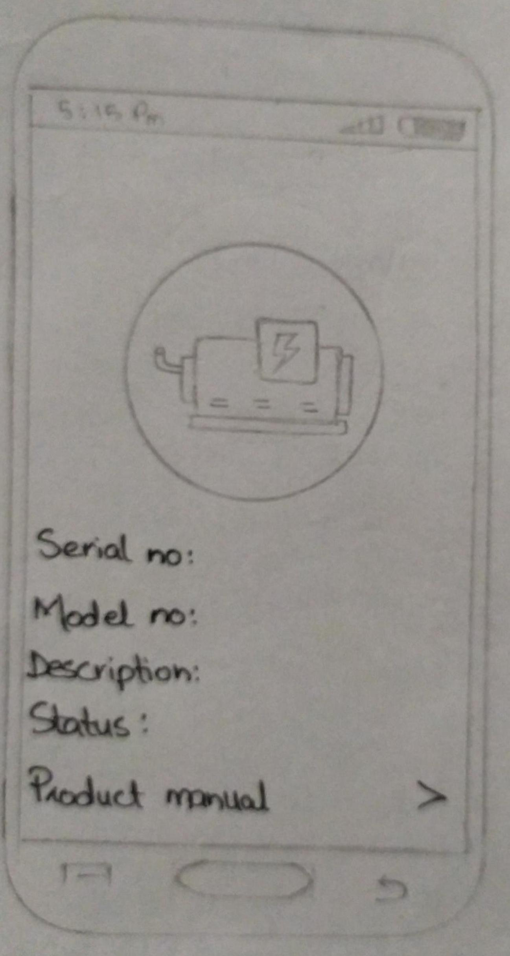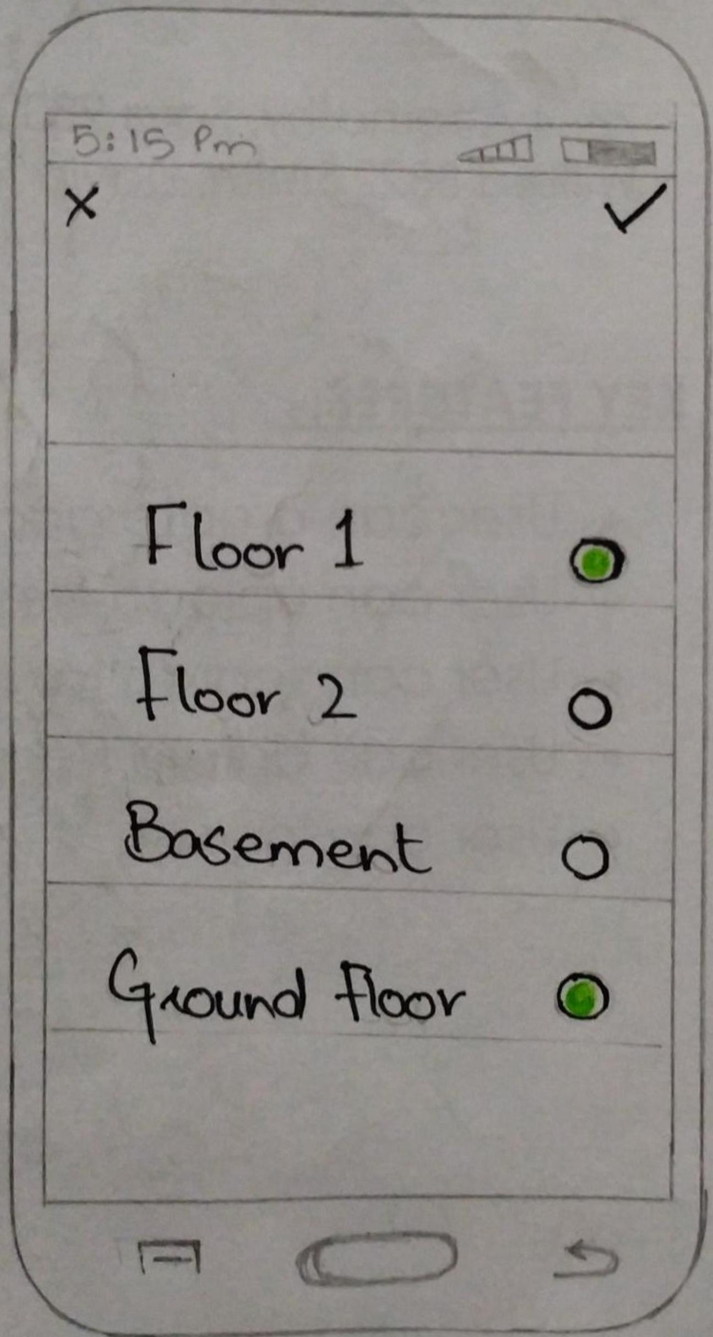

# Personas:

**Name: **

Syed Ali Aslam Naqvi

**Age:**

48

**Qualification:**

Masters

**Profession:**

Business man

**Goals of using this application:**

The goal of using this application is make life easy. This application will help his family and family members to operate the generator using mobile application in the load shedding. As we all known that some females have fear to operate the generator manually this helps to operate easily. The second most problem which the people face is petrol or oil issue that the people can’t able to evaluate that when will the petrol or oil will finished But through this application they will get able to get the notification for the low petrol and oil so they can refill it.

****

**Name:**

Zeeshan khan

**Age:**

27

**Qualification:**

Bachelors

**Profession:**

You tuber

**Goals of using this application:**

This application will not irritate him when he will work and he didn’t want to go near the generator to open or close again and again and this will not affect his work he can easily generate the generator just by clicking one button and he also have one bonus point to divide the voltages among the floors and he can select that how much voltages he wants to do his work and the remaining voltages he divided to the rest of his house.



**Name:**

Ayesha Nazim

**Age:**

30

**Qualification:**

Masters

**Profession:**

Teacher

**Goals of using this application:**

This application will be useful because whenever she wants to get service of a generator so she can easily call the customer service and the workers will come to her home and do the service in front of her eyes and if her generator will not work properly so they can also fix that problem. She don’t have to find some good workers nearby her house

# Cognitive Walkthrough:

When I will open the application a window will pop which tells you to start the application after clicking on let’s start it will connect your generator with mobile through wifi after your generator is connected with your mobile phone it will tell you to move forward and we can turn the power on when we click on turn on our generator will be started after that a new window will be opened it will ask you whether you want to see stats of your generator or you want to put your generator on stand by and you can also check your fuel of your generator. To see your generator states you can swipe right a new window will appear where you can see your states of your generator for to see generator fuel you have again swipe right after that you can divide the voltage of your generator according to the floors by swiping right and after dividing your voltage you can right swipe on the top left side off your app there is a menu bar you check the model of your generator and it will provide a guide to operate the application successfully.

# UI:

